Lab4

a)What are the main phases in the database design? What is done on each development phase?

# 1. Conceptual design

When every data requirement is stored and analyzed, the next thing that we need to do is creating a conceptual database plan. Here, a highly leveled conceptual data model is used. This phase is called *conceptual design*.When the conceptual design phase is in progress, the basic data modeling operations can be deployed to define the high-level user operations that are noted during analysis of the functions.

# 2. Logical Design

The logical phase of database design is also called the data modeling mapping phase. This phase gives us a result of relation schemas. The basis for these schemas is the ER or the Class Diagram.To create the relation schemas is mainly mechanical operation. There are rules for transferring the ER model or class diagram to relation schemas.

# 3. Normalization

Normalization is, in fact, the last piece of the logical design puzzle. The main purpose of normalization is to remove superfluity and every other potential anomaly during the update.Normalization in database design is a way to change the relation schema to reduce any superfluity. With every normalization phase, a new table is added to the database.

# 4. Physical Design

The last phase of database design is the physical design phase. In this phase, we implement the database design. Here, a DBMS (Database Management System) must be chosen to use.For instance, different DBM systems have different names for every datatype and they have different data types.SQL clauses are written to help in creating the database. Also, the indexes and the integrity constraints (rules) are defined in this phase. And finally the data is added and the database can finally be tested.

b)What is the entity-relationship(ER) data model?

[**Entity–relationship model**](https://en.wikipedia.org/wiki/Entity%E2%80%93relationship_model)

An entity–relationship model (or ER model) describes interrelated things of interest in a specific domain of knowledge. A basic ER model is composed of entity types (which classify the things of interest) and specifies relationships that can exist between entities (instances of those entity types). In software engineering, an ER model is commonly formed to represent things a business needs to remember in order to perform business processes.

2.a

b.

3.

One to Many

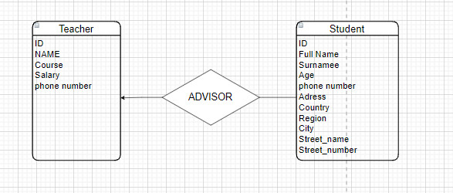

Many to One

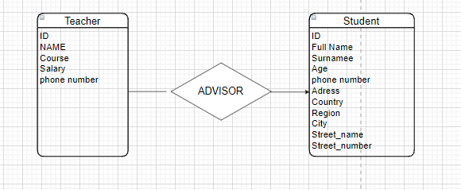

Many to Many

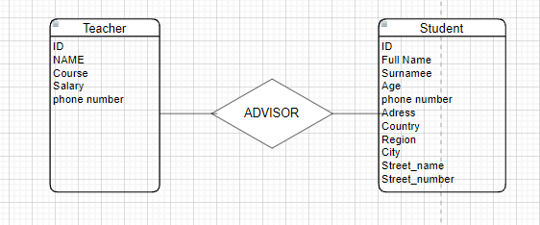

4.

